
Warm Up Naturally

Spice It Up!
Cinnamon, cloves, ginger and pepper are warming spices. Ground cinnamon can be added to add flavor to many baked foods. Cinnamon sticks give a wonderful taste to many warm beverages, such as tea.
Cloves are warming and a great mouth freshener. Because they have antiseptic properties, they not only help with bad breath, but can also keep other parts of your body healthy.
Ginger can be added to soups or vegetables
Pepper just yells out warmth! Sprinkle a little pepper onto foods instead of salt
Honey is effective when it comes to warming the body. It is a natural sweetener that can be added to just about anything sugar is used in. Honey is also great for the complexion
Onions and garlic are easy to incorporate into most meals. These little gems not only help in keeping the body warm but can also be helpful in keeping the body healthy. Have a cold? Try a little garlic to open up those stuffy noses. Lowering cholesterol is also one of the benefits of garlic and onions.

If you answered yes you are not alone. We all feel the cold differently especially during these frigid winter months but did you know that what you are eating can affect your body temperature? Thermogenic foods; Otherwise known as heat producing foods, Have the ability to warm the body by assisting it to create an increased amount of internal heat. Some of these foods include:
- Complex Carbohydrates- Warm the body due to their quick absorption. Look for them in vegetables, whole meal bread and cereals. Examples of foods that contain complex carbohydrates include spinach, yams, broccoli, beans, zucchini, lentils, skimmed milk, whole grains and many other leguminous plants and vegetables
- Fruits and Vegetables- Keep the body warm with their high anti-oxidant, mineral and vitamin content. Some of these include oranges, pomegranates, strawberries, onions, beets, broccoli, cabbage, pumpkin, sweet potato and beans. Try to eat them occasionally raw, as the body produces more internal heat in digesting raw foods.
- Whole grains- Such as oats, quinoa, brown rice and whole wheat are rich in phytochemicals, fiber and other nutrients that help ensure heightened body warmth.
- Seeds and Nuts- Rich in omega 3 fatty acids also contribute to keeping the body warm.

Need Rapid Heat?

- Hot teas and soups warm the body quickly.

- Foods high in Chili and Tabasco offer a short-term, rapid heat blast to the body, but lose their effect as quickly as the give it.

Spice It Up!
Cinnamon, cloves, ginger and pepper are warming spices. Ground cinnamon can be added to add flavor to many baked foods. Cinnamon sticks give a wonderful taste to many warm beverages, such as tea.
Cloves are warming and a great mouth freshener. Because they have antiseptic properties, they not only help with bad breath, but can also keep other parts of your body healthy.
Ginger can be added to soups or vegetables
Pepper just yells out warmth! Sprinkle a little pepper onto foods instead of salt
Honey is effective when it comes to warming the body. It is a natural sweetener that can be added to just about anything sugar is used in. Honey is also great for the complexion
Onions and garlic are easy to incorporate into most meals. These little gems not only help in keeping the body warm but can also be helpful in keeping the body healthy. Have a cold? Try a little garlic to open up those stuffy noses. Lowering cholesterol is also one of the benefits of garlic and onions.

Nutrition 101
Winter 2014
 5

Feeling Cold?
By: Lorraine Kunick

Karen Goldberg RDN CDE, 573 Valley Rd Suite 4C, Wayne NJ, 07470

973-646-8899

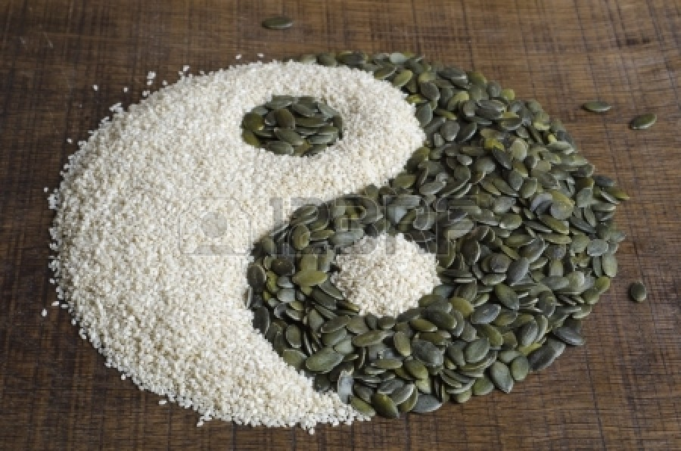

Go all Natural:
There are many herbs that may be added to your cooking, drunk as a tea, taken in a capsule or tincture form. Some of these include:
- Cardamom
- Cayenne
- Coriander
- Cumin
- Fennel
- Horseradish
- Nutmeg
- Turmeric
Foods to Avoid in Winter
Not all foods are the greatest if warmth is what you’re after. There are some foods that should be avoided in order to stay toasty in the winter. Foods that hinder the body’s immune system, cause dehydration and inhibit digestion should be avoided in the winter months. This is largely because they cause the body to concentrate on detoxifying rather than creating an increased amount of heat. Foods that should be avoided when possible include coffee, refined sugars and fried foods. Also remember not to overeat on a cold winter night. Overeating can jump start your metabolism which burns off the extra calories needed to keep the body warm. It can also extinguish digestive fires which help in fending off the chill.

Other foods that should be avoided include:
• White breads
• Cucumbers
• Too much butter
• Cold drinks
• Rice (especially at night)
• Alcohol
• Processed chips
These foods can also heighten metabolism and add to your blustery feeling.
These are just a few of the foods to eat and to avoid during those cold winter months. The next time you curl up in front of the TV with a warm blanket to fight off the winter chill, try snacking on a few of the foods listed above to help keep you warm. You’ll be surprised at how changing your diet can change your temperature making you feel nice and cozy during these frigid winter months. =)

Seeds such as sesame, pumpkin and fennel are great body warmers. Sesame seeds can be incorporated into many dishes, such as green beans or chicken. Pumpkin seeds are great as a snack when roasted. Fennel seeds can also be added to foods.

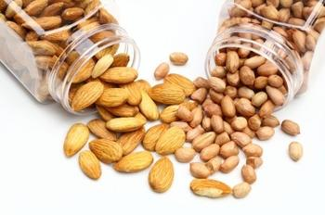

““Let food be thy medicine and medicine be thy food”
― Hippocrates
• 10 soaked almonds or a handful of peanuts can give the body deep warmth that lasts.

