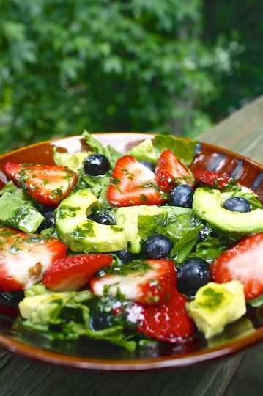
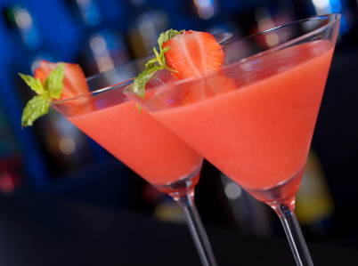
Karen Goldberg, RDN, CDE
Summer is here, which means constant barbeques, happy hours, and family gatherings are around the corner. A lot of foods and beverages consumed during the summer season can be very high in calories and fat. Being around family and friends with the smell of the barbeque filling the air can easily tempt us to overindulge in these warm weather appeals. Although it may be difficult to resist the frozen margaritas and hotdogs, here are some tips to help you stay on track with your diet while barbequing this summer!
- Try to choose grilled chicken more often than hotdogs and hamburgers.
- Chicken is a leaner protein and you will save an extra 100-200 calories by skipping out on the bun.
- Don’t mindlessly snack on the many bowls of chips all over the table.
- Choose raw or grilled veggies instead.
- Try your favorite beers but in their lighter form.
- If you’re drinking liquor, use low calorie mixers such as seltzer, water, and light juices or teas.
- Use as little sauce as possible
- Calories from sauces can add up quickly. Try to stick with mustard or a tiny bit of ketchup if needed.

Summer is Finally Here!

Healthy summer salad ideas
- Easy to prepare and perfect for barbecues!

Low calorie summer cocktail recipes
- Enjoy a tasty cocktail without breaking your diet!

Nutrition 101
Summer 2015

Includes:
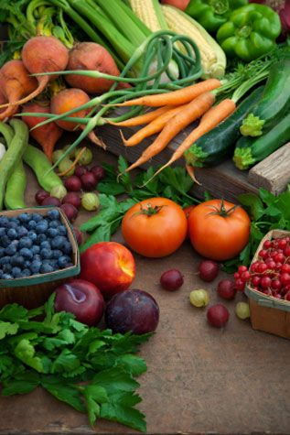

Healthy Summer Salad Ideas

With no cooking required, these salads are easy and perfect for large gatherings.
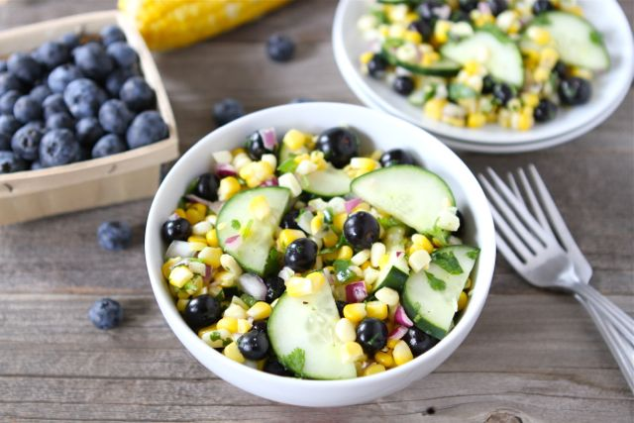Blueberry Corn Salad
This is a simple summer salad made with blueberries, sweet corn, sliced cucumbers, finely chopped cilantro, jalapeño, and red onion and drizzled with a honey lime dressing. To make the dressing, whisk together 2 tablespoons lime juice, 2 tablespoons olive oil, 1-tablespoon honey, ½ teaspoon ground cumin, ½ teaspoon salt, and ¼ teaspoon of black pepper. Serve cold and enjoy!
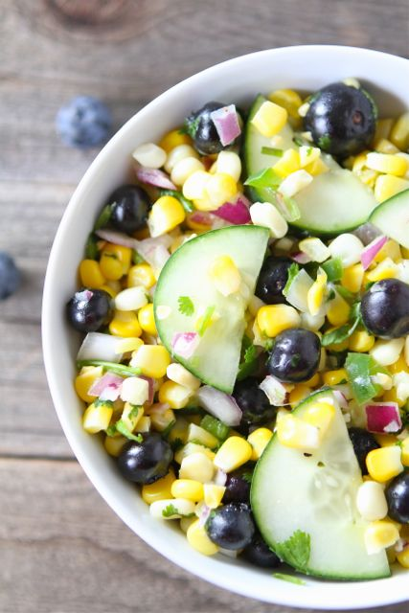

Drink Up!
Who doesn’t love to enjoy a nice cold drink in the summertime? As delicious as these drinks may be, it is easy to start racking up the calories in just one sitting. Many popular cocktails can contain more calories that a cheeseburger! To celebrate the warm weather without adding to your weight, try one of these low-calorie cocktails!
Mini Margarita 80 calories
Keep it simple and make your own margarita by squeezing a couple of limes and orange wedges into a small glass. Add 1 oz. of tequila and maybe a splash of sweet and sour mix!

Cosmopolitan Lite 75 calories
Use about 1 oz. of cranberry flavored vodka. Squeeze a wedge each of lime and orange and then top it off with club soda and serve on the rocks!

Strawberry Daiquiri 135 calories
Usually strawberry daiquiris contain very little fruit and a whole lot of other sweeteners, which can add up to 350 calories. Instead, try pureeing 1 cup of strawberries in a blender with 1 oz. of light rum. Add a handful of ice cubes and sprinkle of sugar.
Tomato, Cucumber, Avocado Salad
Chop up some tomatoes and dice the cucumber and avocado. Sprinkle some feta cheese as well as some red onion. Add a handful of parsley with some olive oil and red wine vinegar and your salad is good to go!
Triple Berry Salad
This salad is made with strawberries, blueberries and raspberries tossed over baby spinach. Add sliced almonds and some chopped basil. Dice up an avocado and then top it off with a little bit of goat cheese. Try with light raspberry vinaigrette!
byline
[Name]
Integer metus.
Lorem.

