
Five Fall Foods to Fight Inflammation

- Pears - the skin of a pear contains more phenolic phytonutrients then its flesh. These include antioxidants and anti-inflammatory flavonoids as well as cinnamic acids and other anticancer phytonutrients.

- Blueberries – the flavonoids found in plants and fruits protect the watery part of cells. Anthocyanins, one of the subclasses of flavonoids, are mainly found in berries.

- Apples – Triterpene is a compound found naturally in apple peels. This compound has shown to have anti-inflammatory properties

- Pumpkins – The antioxidant beta carotene is found in pumpkin. It can help prevent sun damage to the skin and the antioxidant also has anti-inflammatory properties.

- Squash winter squash contains specially structured polysaccharides that researchers are looking at for their antioxidant, anti-inflammatory and antidiabetic properties.



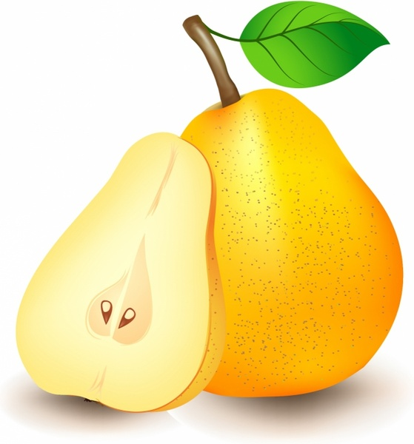
Pumpkin and Pear Soup
From cleaneating.com
- 2 firm ripe pears, divided
- 2 tbsp olive oil
- 1 3 1/2-lb cooking pumpkin, peeled, seeded and cut into 1/2-inch cubes (about 7 1/2 cups)
- 1 yellow onion, finely chopped
- 2 tbsp finely chopped fresh sage leaves
- 1/2 tsp ground allspice
- 1/2 tsp each sea salt and fresh ground black pepper, plus additional to taste
- 5 cups low-sodium chicken or vegetable broth
- 1 tbsp fresh lime juice
INSTRUCTIONS:
- Dice 1 1/2 pears and set aside. (NOTE: If making in advance, cover and refrigerate remaining half pear until needed.)
- In a 6-qt stockpot on medium-high, heat oil. Add pumpkin and cook, stirring occasionally, for 2 minutes. Add onion and cook, stirring occasionally, for 4 minutes. Stir in diced pear, sage, allspice, 1/2 tsp each salt and pepper and cook, stirring occasionally, until vegetables are crisp-tender, about 4 minutes. Add broth, scraping up any browned bits in the pot with a spoon. Bring to a boil, then reduce to a simmer and cook until pumpkin and pear are very tender, 6 to 8 minutes.
- Using an immersion blender, carefully purée soup. (Alternatively, purée soup in an upright blender, in batches, remove plastic lid in cover and cover top with a kitchen towel to allow steam to escape.)
- Cut remaining half pear into matchsticks. In a medium bowl, combine matchsticks with lemon juice, stirring to coat. Cover matchsticks and set aside in the refrigerator until needed.
- To serve, reheat soup on medium, stirring occasionally, until heated through. Season with additional salt and pepper. Garnish with pear matchsticks.
Nutrients per serving (1 cup Pumpkin & Pear Soup and 1 tbsp pear matchsticks): Calories: 84, Total Fat: 3 g, Sat. Fat: 1 g, Monounsaturated Fat: 2 g, Polyunsaturated Fat: 0 g, Carbs: 14 g, Fiber: 2 g, Sugars: 6 g, Protein: 1 g, Sodium: 168 mg, Cholesterol: 0 mg

